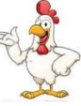Pollito, chicken 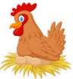Gallina, hen

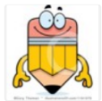Lápiz, pencil Y pluma, pen

Ventana, window 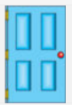Y puerta, door

Maestra, teacher 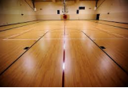Y piso, floor.